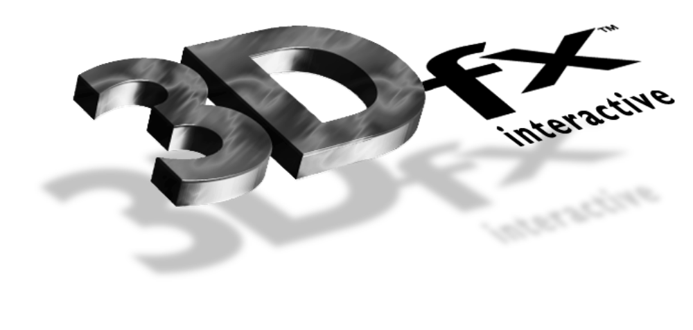

Release Notes

3Dfx Interactive Arcade Toolbox

ATB Version 0.2
21 June 1996
Copyright © 1995, 1996 3Dfx Interactive, Inc. All Rights Reserved

3Dfx Interactive, Inc.
415 Clyde Ave., Suite 105
Mountain View, CA 94043
Phone: (415) 934-2400
Fax: (415) 934-2424

Installation
Compilers
Compiling ATB Programs
Hardware Support
Obsidian™.
Righteous 3D™ .
Operating Systems
DOS Notes
Windows®95 Notes
Windows NT® Notes
Demo Programs
Bugs
Bug Reporting
New Routines
New Features
Behavioral Changes

Installation
Please see the document titled Installing and Using the Obsidian™ High Performance 3D Graphics Accelerator for installation instructions. Glide version 2.0b3 should have been installed previously.

Compilers
Supported Compilers Are:
- Microsoft® Visual C++ Version 2.2 for Windows95 and Windows NT.
- Watcom C/C++ 10.5a for Windows 95, Windows NT, and DOS.
ATB has also been compiled and built using MSVC 4.1.

Compiling ATB Programs

Include And Library Files
The following header files are necessary to interface to each of the components of the Arcade Toolbox.
LIBRARY | HEADER | LIB
Utility | atutil.h | atu.lib
Math | atmath.h | atm.lib
Input | atinput.h | ati.lib
Rendering | atrender.h | atr.lib
Scene Management | atscene.h | ats.lib

Path
On DOS, dos4gw.exe must be in your path. On Windows, sst1init.dll and glide.dll must be in your path.

Hardware Support
Glide and ATB support the following products:

Obsidian™
Glide 2.0b3 supports either one or two Texelfx chips (Amethyst™) . Further, it supports DACs from either ICS or AT&T.

Righteous 3D™
This release of Glide supports the Righteous3D board from Orchid.

Operating Systems
ATB supports Windows95, Windows NT and DOS. There is no native support in the development release for OS/2 or Linux.

DOS Notes
Glide, and therefore ATB, does not support the DOS/4GW Virtual Memory Manager(VMM) in stand-alone DOS shells.

Windows95 Notes
If you are running under Win95 and you have less than 24MB of RAM you must change your DOS properties settings. The value for DPMI memory must be changed from AUTO to 16384. The initial environment setting must also be changed from AUTO to a minimum of 4096 for some demos.

Windows NT Notes
Glide programs built for DOS4GW cannot be run under Windows NT.

Demo Programs
The following demos are present on the CD:
atsflip - a simple model viewer that allows you to load files in a number of different formats
fight - uses ATB to create a fighting demo that demonstrates many of the advanced features of the 3dfx hardware including: texture mapping, bilinear filtering, mip mapping, dynamic lighting, fog.
wiz - demonstrates the use of lighting maps to produce high quality textured environment’s. There are 5 rooms to explore
Note: neither fight or wiz require any environment variables to be set to determine the location of their data files. If you set FIGHT_LOAD_PATH (or WIZ_LOAD_PATH) ensure that the fight.bof (wiz.bof) file is located in the specified search path. If these variables are not set the program assumes the data files are in the same directory as the executable (which is where the setup program installs them).
The program atsflip does use an environment (AT_LOAD_PATH) to determine where the files to be viewed are located. This variable is setup by the batch files provided in the flip directory. To view other files simply set this variable to the directories containing the files.
The environment variable SST_DUALHEAD can be used in all the demos to disable setting of the pass through mode when using two separate monitors (one for displaying windows and one for displaying the demo graphics).

Bugs

Bug Reporting
At this time ATB is provided in source code form on as-is basis and is NOT a supported product. If you have any questions or suggestions for enhancements please forward them via electronic mail to devsuppor@3dfx.com. Your comments will be reviewed and considered. 3Dfx Interactive does not guarantee that your questions will be answered nor your suggestions be included in future releases.

New Routines
atrXformSetRotation() - Create a rotation about an arbitrary axis.
atrEnvFogTable() - Initialize the fog table in an AtrEnv structure.
atrQueryVoodooCaps() - Query the configuration of the current Voodoo Graphics subsystem.
atrRenderTriWF() - Render an immediate mode triangle as a wireframe.
atrRenderTriSetWF() - Render an AtrTriSet as a wireframe.
atrDrawString() - Render a string in a primitive font to the specified location on the screen.

New Features

New Light Types
Two new light types have been added.
New input library all of the old input routines have been replaced preliminary documentation is provided with this release.
The old objlib graphics database has been replaced by a new scene manager. Documentation on this will be available shortly.
Positional - Light whose position is accounted for in the vertex lighting equation. Distance attenuation is not computed for this type of light.
Attenuated - Positional light with distance attenuation.

New Material Properties
The specular color and specular exponent field in the material structure now control a per-vertex specular lighting computation.

Behavioral Changes

Materials
All of the material fields related to texture mapping have been expanded to arrays to accommodate multiple texture mapping units on the Voodoo Graphics hardware.

